Progress Report APT Project (Phase 2)

Maintenance, Works, and Assets Management System
Hotel & Centro de Eventos El Almendro

Students:
Bruno Víctor Carpio López
RUT: 24.793.696-3
Pablo Andrés Gamboa Huechucoy
RUT: 21.666.746-8
Benjamín Alexander Salinas Vallejos
RUT: 21.438.360-8
Course: Capstone PTY4614
Section: 003-D
Teacher: Paz Constanza Morales Saavedra

Abstract (Español) 3
Abstract (English) 3
1.Introduction 4
2. Current State of the APT Project 5
3. Adjustments made to the project 5
3.1 Difficulties encountered 6
3.2 Factors that facilitated the development 6
3.3 Feedback received 7
3.4 Adjustments made 7
4. Work Methodology 7
5. Development Progress 8
5.1 Web system development 8
5.2 Database 8
5.3 Information migration 9
5.4 Developed functionalities 9
6. Evidence of progress 10
7. Disciplinary quality indicators 11
8. Aspects to improve and next steps 12
9. Conclusions Individual 13
9.1 Individual Conclusions: Pablo Gamboa 13
9.2 Individual Conclusions: Bruno Carpio 13
9.3 Individual Conclusions: Benjamín Salinas 14
10. Reflection – Individual 14
10.1 Individual Reflection: Pablo Gamboa 14
10.2 Individual Reflection: Bruno Carpio 15
10.3 Individual Reflection: Benjamín Salinas 15
11. Bibliography 16
12. Evidence Annexes 17

Abstract (Español)
El presente informe muestra el avance de la segunda fase del Proyecto APT desarrollado para el Hotel y Centro de Eventos El Almendro. El proyecto consiste en el desarrollo de un sistema web orientado a mejorar la gestión de mantenciones, obras, mejoras y activos del establecimiento, permitiendo centralizar información que anteriormente era administrada principalmente mediante distintos archivos Excel.
Durante esta etapa se avanzó en el desarrollo de la interfaz web, la implementación de la base de datos en Supabase y la migración de información real entregada por el cliente. También se realizaron ajustes a la propuesta inicial a partir de las dificultades encontradas, la retroalimentación recibida y las necesidades que fueron apareciendo durante el desarrollo.
Uno de los principales cambios realizados fue pasar desde una metodología inicialmente planteada como híbrida a trabajar completamente con Scrum, utilizando Sprints para organizar y dar seguimiento a las actividades del proyecto. Además, se continuó mejorando la estructura del sistema y la organización de la información para que esta represente de mejor manera los procesos del cliente.
Actualmente el proyecto cuenta con una base de datos que contiene información real del establecimiento y con distintos módulos que se encuentran en proceso de integración con la aplicación web. Durante las siguientes etapas el trabajo estará enfocado principalmente en completar esta integración, realizar pruebas y validaciones, mejorar la documentación y preparar el sistema para su utilización por parte del cliente.

Abstract (English)
This report presents the progress made during the second phase of the APT Project developed for Hotel & Centro de Eventos El Almendro. The project consists of the development of a web-based system aimed at improving the management of maintenance activities, works, improvements, and fixed assets, centralizing information that was previously managed mainly through different Excel files.
During this stage, progress was made in the development of the web interface, the implementation of the Supabase database, and the migration of real information provided by the client. Several adjustments were also made to the initial proposal based on the difficulties identified, the feedback received, and the new needs that emerged during the development process.
One of the main changes was moving from an initially proposed hybrid methodology to a full Scrum approach, using Sprints to organize and monitor project activities. In addition, the system structure and data organization continued to be improved in order to better represent the client’s actual processes.
Currently, the project has a database containing real information from the organization and several modules that are being integrated into the web application. The next stages will mainly focus on completing this integration, performing tests and validations, improving the documentation, and preparing the system for its final use by the client.

1.Introduction
The APT Project aims to develop a web solution to support the management of maintenance, works, improvements, and assets for the Hotel and Events Center El Almendro. The need for the project arises because much of this information was distributed across different Excel files, making it difficult to consult, update, and track.
During the early stages of the project, requirements gathering was conducted with the client, and an initial prototype was developed that allowed validating the visual proposal and the main functionalities of the system. Based on this feedback, the development of the application continued, and the incorporation of real information provided by the client began.
In this second phase, the work has mainly focused on improving the system structure, implementing the database, migrating the existing information, and making progress in the integration of the different modules of the application. At the same time, adjustments have been made to the work methodology and planning, seeking to maintain a more organized development adaptable to changes that may arise.
This report describes the main progress achieved, the changes made during development, the methodology used, the evidence generated, and the aspects that still need to be improved during the next stages of the project.

2. Current State of the APT Project
Currently, the project is in a development and integration stage. The main structure of the web application has already been created, and there are different views related to maintenance, remodeling, improvements, assets, and information visualization through a dashboard and Gantt chart.
During this phase, one of the most important advancements has been working with real information provided by the client. For this, it was necessary to review the different provided files, identify their structures, and subsequently organize the information to be incorporated into the database.
The database is implemented using Supabase and currently stores information corresponding to maintenance, inventories, remodeling, future projects, gardening, risk prevention, suppliers, and other records related to the facility's operation.
Progress has also been made in connecting the web application with Supabase. Some modules already work with real information from the database, while others are prepared to continue their integration during the next stages.
The project maintains the objective that the client can consult and manage this information from a single platform, progressively reducing the dependence on the different Excel files previously used.

3. Adjustments made to the project
During the development, different adjustments have been made regarding the initial proposal. These changes arose mainly from the difficulties encountered, the feedback received from the teacher and the client, and the analysis conducted during the system's progress.

3.1 Difficulties encountered
One of the main difficulties was working with the information provided by the client. The Excel files presented different structures among themselves, with different sheets, columns, comments, and ways of recording information. This made it necessary to conduct a preliminary review before starting the migration to the database.
Another difficulty was correctly defining the structure of some modules, because during the development there was a better understanding of how the client actually organizes their activities. For example, Gardening and Risk Prevention initially could be interpreted as separate areas, but later it was defined that both correspond to subsections within General Maintenance.
It was also necessary to adjust some parts of the initial prototype to be able to work later with real data and not just with simulated information.

3.2 Factors that facilitated the development
One of the main factors that has facilitated the progress of the project has been the communication among the team members, as it has allowed distributing the activities and jointly resolving the difficulties that have appeared.
It has also been important to maintain contact with the client, since the information and feedback provided have allowed a better understanding of how maintenance, works, inventories, and projects are currently carried out within the facility.
Another factor that has helped the development has been the use of tools like Git for version control, Supabase for storage and organization of information, and the development tools used by the team. This has allowed maintaining greater order and making changes without losing the progress previously made.

3.3 Feedback received
During the development, feedback has been received from both the teacher and the client. This feedback has allowed correcting some aspects of the planning and improving the way the system is represented.
One of the most important changes was reviewing the methodology used. Initially, the project was presented using a hybrid approach, but later it was determined that the working method used by the team corresponded better to Scrum, due to the use of Sprints, Product Backlog, reviews, and constant adaptation to changes.
Observations related to the structure and presentation of the project have also been received, including the need to improve the architecture diagram to more clearly represent the current functioning of the system.

3.4 Adjustments made
Based on these difficulties and feedback, different adjustments were made. Scrum was defined as the project's work methodology, the structure of some modules was reorganized, the data model was improved, and work began with real information provided by the client.
A progressive review and migration of the original files to Supabase was also carried out, ensuring the preservation of historical information and original values when there was incomplete or difficult-to-interpret data.
In addition, updating the architecture diagram to correctly reflect the current structure of the system and the relationship between the web interface, the application logic, and the database remains a pending improvement.

4. Work Methodology
For the development of the project, Scrum is used, an agile framework that allows organizing activities through work cycles called Sprints and facilitates adaptation to changes during development (Drumond, n.d.).
The work is organized through Sprints, in which the tasks to be developed during a specific period are defined. These activities are obtained from the Product Backlog and prioritized according to the project's needs.
At the beginning of each Sprint, the tasks to be developed are reviewed and distributed among the team members. During the development, communication is maintained to review progress and resolve difficulties. At the end, the results obtained are reviewed, and possible improvements for the next Sprint are identified.
Within the team, Pablo Gamboa fulfills functions related to general coordination, interface development, and system integration. Benjamín Salinas participates mainly in monitoring the Product Backlog and development, including work associated with the backend. Bruno Carpio participates mainly in review, testing, and validation activities.
Scrum has allowed adapting the project when new requirements or additional information from the client appear, without losing the general organization of the work.

5. Development Progress

5.1 Web system development
A web application has been developed using HTML, CSS, and JavaScript. The application has different views that allow organizing the system's information through an interface based mainly on cards, forms, and visual sections.
Currently, there are views related to the dashboard, maintenance, remodeling, improvements, assets, and a Gantt chart. Some of these sections already use real information from Supabase, while others are in the process of integration.

5.2 Database
The database is implemented using Supabase, utilizing PostgreSQL as the storage system.
During this phase, work was done on creating and adapting different tables needed to represent the client's information. The goal was to maintain a structure that allowed linking elements, maintenance, locations, projects, tasks, inventories, and other records.
In addition, fields intended to keep the original text from the client's files were preserved when necessary, avoiding modifying or losing information during the migration.

5.3 Information migration
One of the main tasks carried out during this phase was the migration of information from the documents provided by the client to Supabase.
Work was done with files corresponding to General Maintenance, Remodeling, and Future Project Improvements. Information related to inventories, bathrooms, controls, televisions, doors, septic tanks, gardening, risk prevention, and maintenance guides was also incorporated.
Because the documents had different structures, the information was reviewed before being incorporated. In cases where there were incomplete values, comments, or dates that could not be interpreted correctly, the original values were kept to avoid modifying the client's information.

5.4 Developed functionalities
So far, progress has been made in the general navigation of the system, authentication, project visualization, management of information related to remodeling, connection with Supabase, and visualization through a Gantt chart.
The necessary information is also prepared to continue integrating General Maintenance and Future Project Improvements directly with the database.
The objective of the next stages is to complete this integration and allow the information to be progressively managed directly from the application itself.

6. Evidence of progress
During this phase, different evidence has been generated that demonstrates progress in both the planning and the technical development of the APT Project.
As part of the initial gathering, there is the matrix of functional and non-functional requirements, where the main needs identified with the client are recorded. There is also a functional web prototype, which has allowed progressively presenting and validating the visual proposal and the main functionalities of the system.
The project development is backed by the BPB team's GitHub repository, which maintains the source code and the changes made during development.
Regarding the database, there is evidence of the structure implemented in Supabase and the process carried out to migrate the information provided by the client from different Excel files. This information includes records associated with General Maintenance, Remodeling, and Future Project Improvements.
To demonstrate the application of Scrum, evidence related to the Product Backlog, the organization of Sprints, and the tracking of activities carried out during each work period will also be incorporated.
Finally, screenshots of the system modules that currently work with real information will be included, as well as the Gantt Chart visualization developed as part of the functionalities requested for the system.
The main evidence is organized in the annexes of this report.

7. Disciplinary quality indicators
According to the graduation profile competencies related to the APT Project, different quality indicators were identified that are present or in development within the system.
- Designs validation tests for both products and processes using good practices defined by the industry: this indicator is in development, as functional reviews have been defined to check the operation of the main system modules, and more structured tests will be conducted later.
- 1.2 Applies validation tests for both products and processes using good practices defined by the industry: partially present. During the development, functional tests and corrections have been carried out based on detected problems, but the final tests have yet to be completed and documented.
- 1.3 Develops product improvements based on test results: this indicator is present, since during development, corrections and adjustments have been made to the application based on identified errors, tests performed, and feedback received.
- 2.1 Plans IT projects according to the organization's requirements: present through the use of Scrum, Product Backlog, prioritization, and activity planning in Sprints.
- 2.2 Controls IT projects according to the organization's requirements: present through tracking tasks developed during each Sprint, reviewing progress, and reorganizing activities when new requirements appear.
- 3.1 Designs data models to support the organization's requirements: present through the design of the data structure necessary to represent maintenance, elements, projects, tasks, locations, inventories, and other information provided by the client.
- 3.2 Implements data models to support the organization's requirements: present through the implementation of the model in PostgreSQL using Supabase and the progressive migration of the facility's real information.
- 4.1 Builds a software solution using techniques that systematize the development and maintenance process: present through the development of a web application using HTML, CSS, and JavaScript.
- 4.2 Integrates the different components of a software solution: present through the integration between the web interface, the logic implemented in JavaScript, and the Supabase database.
- 4.3 Implements a software solution using techniques that systematize the development and maintenance process: this indicator is in development. Currently, there is a functional version of the system and some modules already work with real information, but the integration, validation, and preparation of the final version for the client still need to be completed.

8. Aspects to improve and next steps
Although significant progress has been made during this phase, there are still aspects that must be completed before finishing the project.
One of them is to finalize the integration of the modules that still use simulated information or that are partially connected to Supabase. It will also be necessary to implement and document functional tests to verify that the main functions of the system work correctly.
Another aspect to improve corresponds to the architecture diagram, which must be updated to more clearly represent the current structure of the system.
In addition, work will continue on validating the migrated information, documenting the project, and preparing the necessary functionalities so that the client can manage the information directly from the platform.

9. Conclusions Individual

9.1 Individual Conclusions: Pablo Gamboa
During this phase of the APT Project, I have been able to participate in different areas of the development, especially in the web application, database integration, and organization of the information provided by the client.
One of the main challenges was working with different Excel files that did not have the same structure. This required reviewing and organizing the information before migrating it to the database. This process helped me understand the importance of designing a system based on the real needs and information of the client.
I also consider the change to Scrum an important improvement because it allowed us to organize the project in a clearer way and adapt the development according to the progress and feedback received.
The project still has tasks to complete, mainly related to the integration of all modules, testing, validation, and documentation. However, the progress made during this phase provides a solid base to continue developing the final solution.

9.2 Individual Conclusions: Bruno Carpio
During this second phase of the project, the transition from simulated data to real information provided by Hotel El Almendro has been our most significant milestone, and it completely changed the dynamic of our work. My primary focus has been on validation, testing, and tracking our progress.
One of the biggest challenges was ensuring that the data migrated from the client's complex and unstructured Excel files was correctly adapted into our Supabase database. We had to do this without losing valuable historical records or misinterpreting the hotel's processes.
To achieve this, I had to coordinate closely with Benjamín regarding the database structure and with Pablo on the frontend. This was crucial to ensure the real data was not only stored securely but also displayed intuitively for the final user.
This constant coordination has been key to stabilizing the system and ensuring that the final platform is perfectly tailored to the tastes and operational needs of our client, Andrés.

9.3 Individual Conclusions: Benjamín Salinas
During this second phase of the APT Project, my primary focus as Backend Developer and Product Owner was the design and implementation of the relational database in Supabase.
One of the most significant challenges we faced was analyzing and migrating the historical data from the hotel's unstructured Excel files into our normalized PostgreSQL database. It was a complex process to ensure no critical historical information or business logic, such as material costs and maintenance tracking, was lost.
As Product Owner, I had to prioritize these data structuring tasks within our Scrum framework. I maintained constant communication with our stakeholder, Andrés, to understand the real operational flow and ensure our architecture matched his needs.
This phase proved that a strong, well-structured backend is essential to successfully transition from a static prototype to a functional system that manages real business data.

10. Reflection – Individual

10.1 Individual Reflection: Pablo Gamboa
During the development of this project, I have learned that creating a software solution involves more than programming the application. It is also necessary to understand the client's information, organize the work, make decisions, and adapt the project when new requirements or difficulties appear.
I believe one of my main contributions has been participating in the development and integration of the system, as well as helping to organize the information that will be used by the application.
One aspect I still need to improve is the organization and documentation of some of the work completed during each Sprint. I also want to improve the architecture diagram so that it clearly represents how the current system works.
For the next stages, I want to continue working on the integration of the real data, perform more tests, and make sure that the final system is useful and understandable for the client.

10.2 Individual Reflection: Bruno Carpio
As I anticipated during the first phase, working with real client data brought a series of new edge cases that were completely invisible when we used perfect, simulated information. Analyzing the different structures of the hotel's Excel sheets taught me a valuable lesson: real-world data is often messy and inconsistent, and migrating it requires deep analysis rather than just writing code.
On a personal level, dealing with these unexpected data challenges has deeply reinforced my commitment to quality assurance. It made me realize that technical bugs or poorly integrated data are not just academic errors; they can actually disrupt a real company's daily operations and maintenance schedules.
For the upcoming final stages, my main goal is to rigorously execute our structured testing matrix across all integrated modules. I want to ensure that the final software we deliver is robust, highly intuitive, and truly reliable for the hotel staff.

10.3 Individual Reflection: Benjamín Salinas
This phase taught me a very practical lesson about the gap between theoretical data models and real-world business information. Dealing with inconsistent and informal Excel sheets made me realize the importance of adaptability and thorough requirement analysis in software engineering.
I am proud of the solid database architecture we have built in Supabase. This structure successfully supports the automated calculation logic and the separation of the six operational areas.
However, I recognize that as a team, we need to improve our branch management in GitHub. We must establish a better version control routine to avoid conflicts when integrating the frontend with the backend.
Looking ahead to the next stages, I want to apply my professional interest in system security. I will focus strongly on implementing robust cybersecurity measures, specifically regarding user authentication and role-based access control, to ensure the hotel's operational data remains strictly protected.

11. Bibliography
Drumond, C. (s. f.). ¿Qué es scrum? Desglose del marco de trabajo ágil. Atlassian.
ISO 25000. (s. f.). ISO/IEC 25010.
OpenAI. (2026). Introducción a ChatGPT. OpenAI Academy.
Pichai, S., Hassabis, D., & Kavukcuoglu, K. (2025, 18 de noviembre). Una nueva era de inteligencia con Gemini 3. Google. La publicación presenta también Google Antigravity como plataforma de desarrollo basada en agentes.

Use of artificial intelligence tools: During the development of the project, artificial intelligence tools were used only for support. ChatGPT was used primarily for proofreading, spelling checks, and rephrasing of report texts (OpenAI, 2026), while Google Antigravity was used as support during programming, error detection, and code organization (Pichai et al., 2025). The requirements, design decisions, architecture, functionalities, and validation of the project were defined and developed by the BPB team.

12. Evidence Annexes
Annex A: Functional and non-functional requirements matrix
Document containing the main requirements identified for the development of the system.
matriz_requerimientos_funcionales
Annex B: Hotel El Almendro Web Prototype
Access to the functional prototype developed to validate the visual proposal and the main functionalities.
Prototipo Pagina Web El Almendro
Annex C: BPB Team GitHub Repository
Repository used to maintain the source code and version control of the project.
Git Hub Equipo BPB
Annex D: Supabase Database
Screenshots of the database structure and the main tables used by the system.
Esquema BDD
Annex E: Product Backlog and Sprint Tracking
Evidence of the planning and tracking of activities using Scrum.
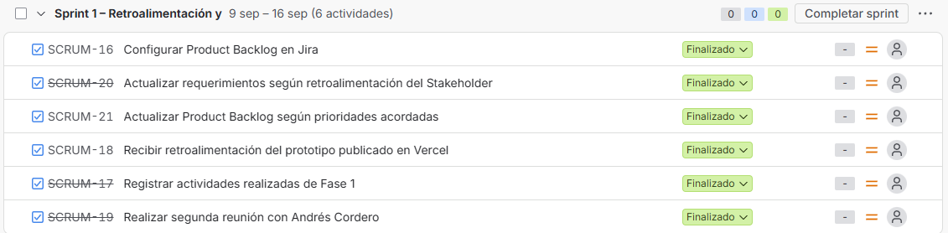
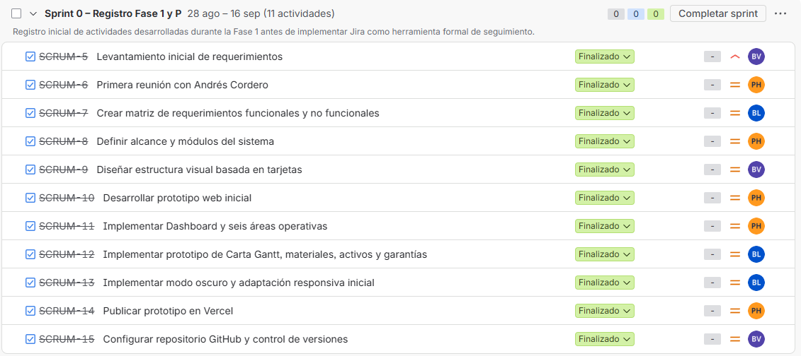
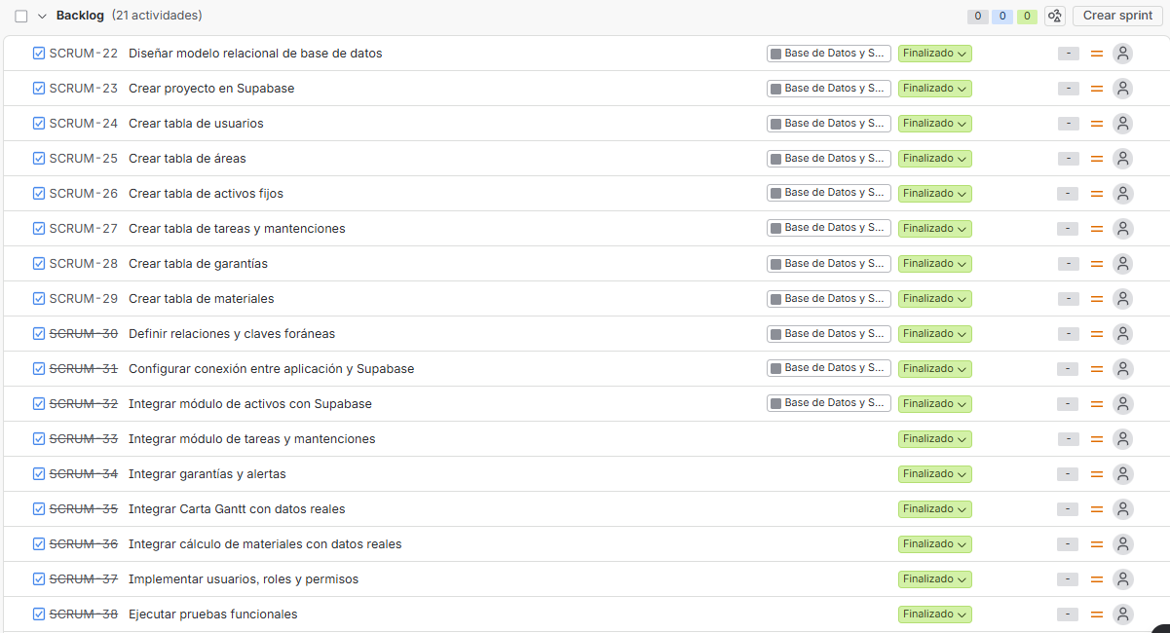
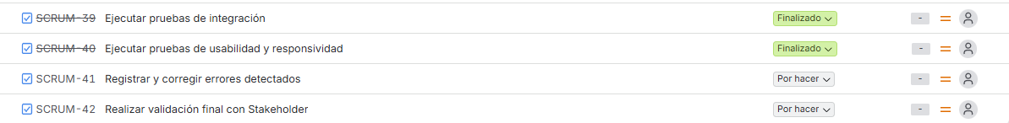

Annex F: Client Information Migration
Evidence of the process of incorporating information from the documents provided by the client into Supabase.
Annex G: Modules working with real information
Screenshots of the different application sections connected to the information stored in Supabase.
Annex H: System Gantt Chart
Evidence of the Gantt Chart visualization implemented as one of the functionalities requested by the client.
